**CASE STUDY 2 REPORT**

**Group Name:** Avengers

**Group Members:**

Mell Edzan Bin Mustapha

Noratysha Abidin

Tunku Shahrin Iman

**Project Title: Heart Disease Dataset**

**Task & Roles:**

Pre-processing:

- Removing outliers

- Identifying and fixing missing values

- Encoding

Machine Learning:

-Machine Learning Design (Mell, Tysha, Shahrin)

-Testing (Shahrin, Tysha)

Deployment:

-Web App Design (Mell,Tysha)

Documentation:

-Slides (Mell, Tysha, Shahrin)

-Demo (Tysha)

**Timeline** 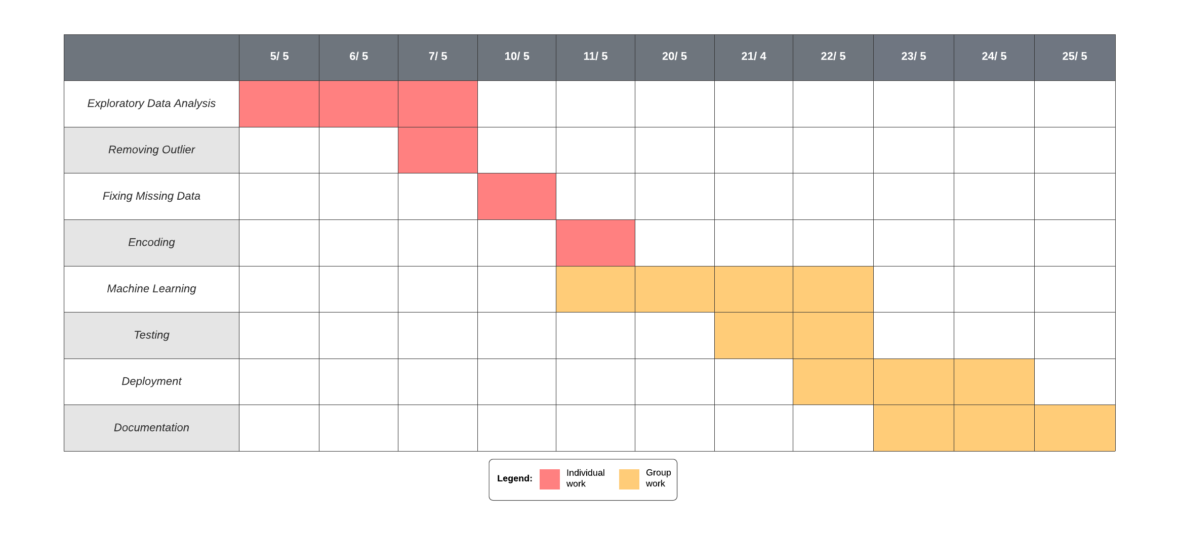

**Issues:**

-Project development interrupted by long holiday inbetween.